Can we automate portal which developed in HTML5 using Selenium:

Able to find and interact with Menu tabs & Breadcrumb. Not able to find XPath for WebElements from PreConfigure the below page.

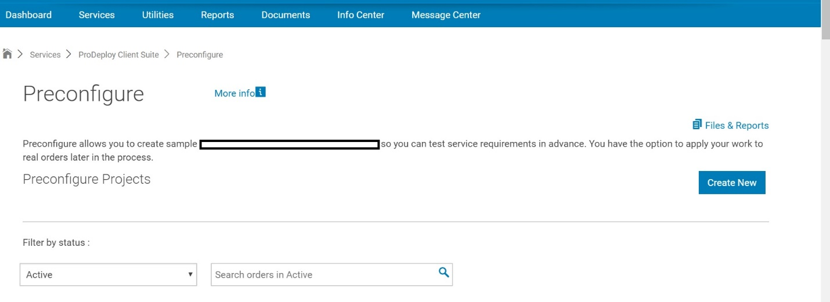

If I select Inspect element getting the below code.

Xpath : //object[@id='ifProDeploy']

Not able move further from <Object> element.

Example:

Able to find xpath for PreConfigure Heading: //h1[text()='Preconfigure']

But not bale to interact that WebElement from selenium. Getting ‘No Such Element Found’ execption.

If I am trying to find xpath from root node, not ablr to mode further from //object[@id='ifProDeploy']

